Ranada, Roman Yrudtud R. 2ECEB-19

2112: Advanced Computer Programming and Algorithms

Experiment 9:

Data Wrangling using Pandas

Problem 1 proof

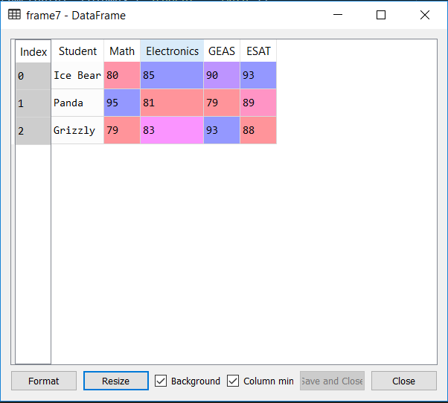

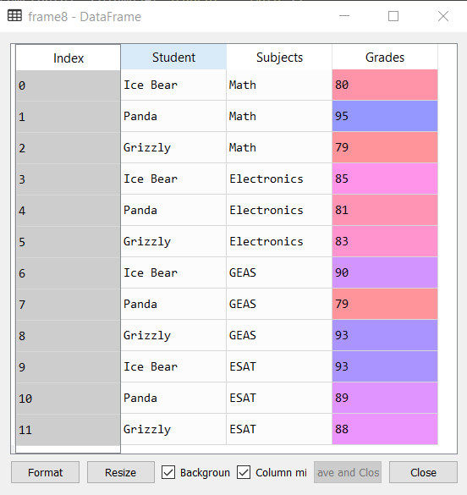

Problem 2 proof

